Task 1: Data Pre-processing
This task involved the preparation of three datasets—Users, Reviews, and Places—for further data processing and analysis. These datasets, though large and semi-structured, required extensive cleaning and formatting before meaningful insights could be extracted. The following data pre-processing steps were implemented:
a. Converting Unstructured to Structured Data:
Many of the fields in the reviews, particularly the reviewText, contained inconsistent formatting. First the files were renamed to place.csv, reviews.csv and users.csv respectively. Then the panda library was used to read the files and structure using the tab (“\t”) as a delimiter to separate and structure the headers. This method was used because it’s basic the formatting is done automatically.
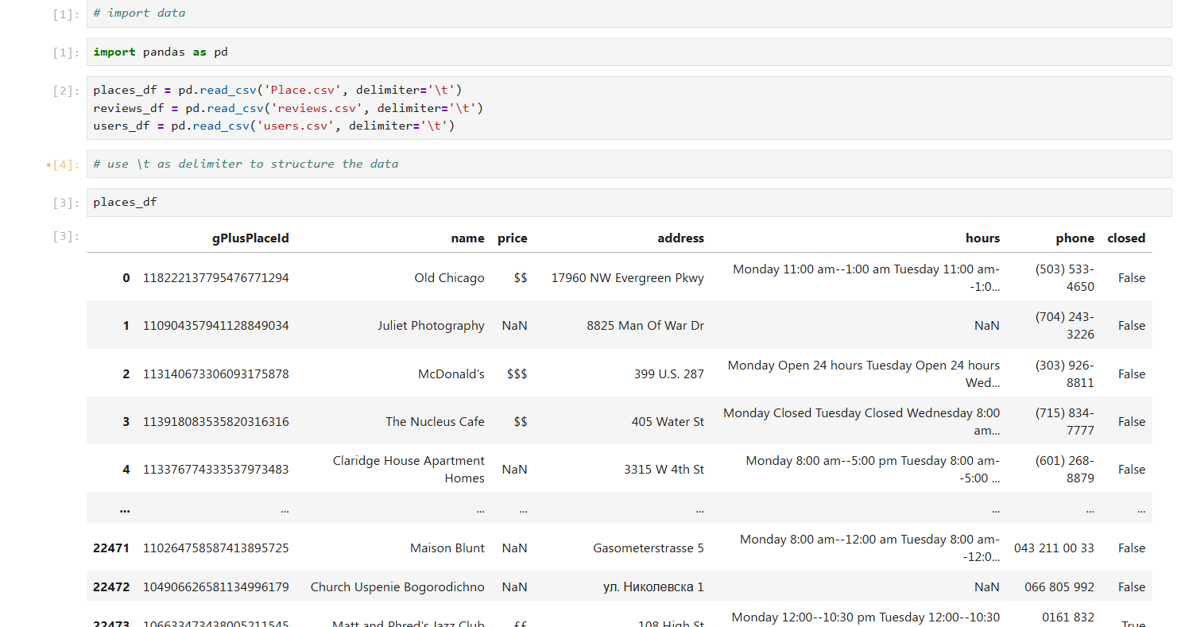

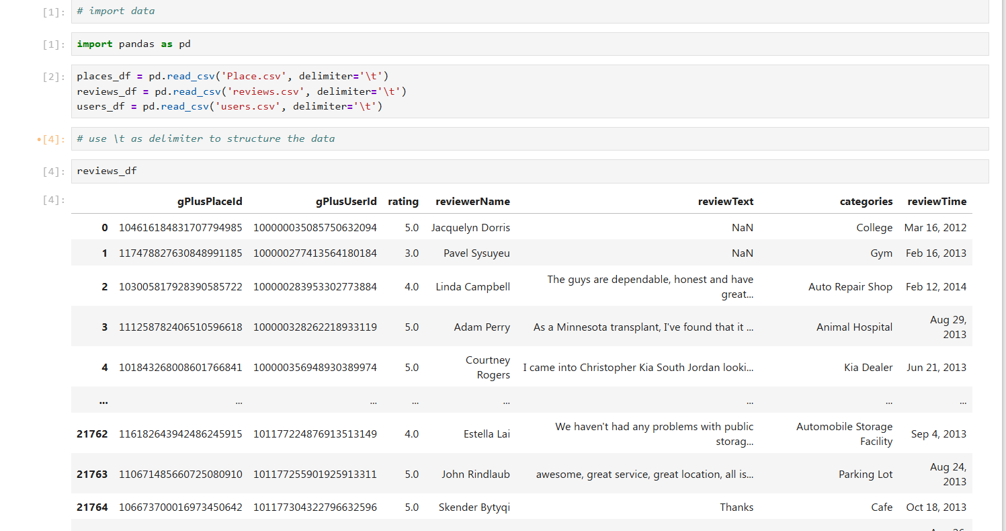

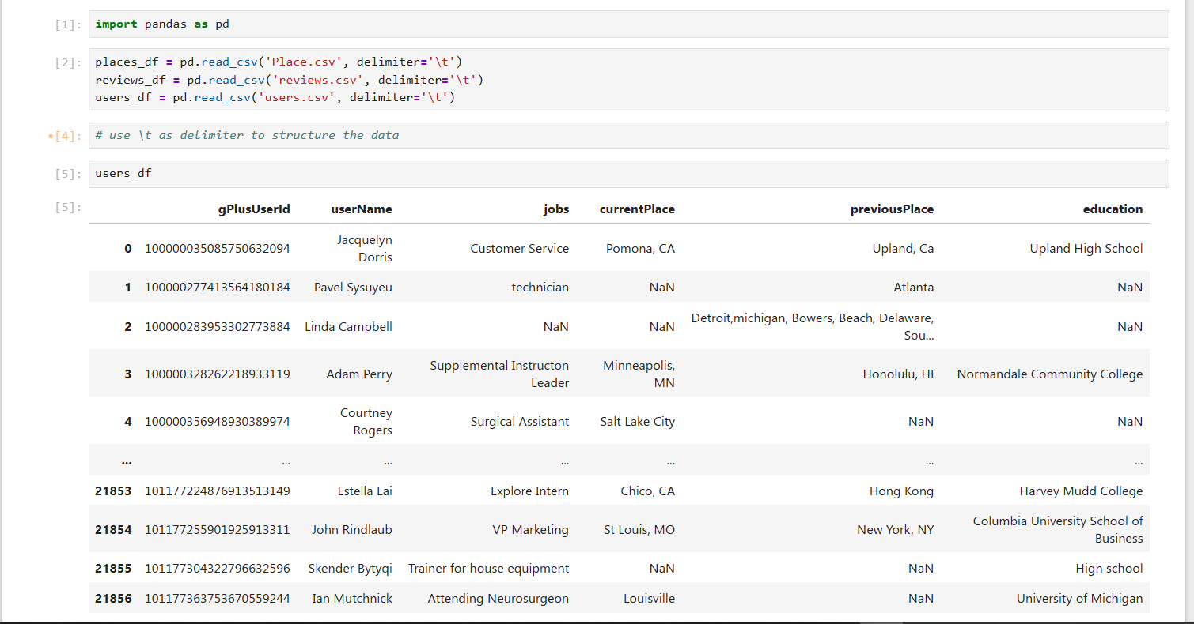

b. Removal of Nan values:
c. Spell Correction:
Python’s TextBlob library can be used for the review text data to perform automatic spell correction. TextBlob library, however, has its limitations with a major limitation being its slow processing of data. Its slowness to processing data is mainly cased by:
- Processing Each Word: The TextBlob library analyzes every word in the text to determine if it needs correction, which can be slow for longer texts.
- Language Model Complexity: TextBlob relies on machine learning models to identify spelling errors, and checking accuracy takes time.
- Computational Power: If your system has limited processing power or is running other tasks, performance might be slower.
- Large DataFrames: Applying corrections to thousands of entries will take time since each row is individually processed.
To speed things up the pyspellChecker library was implemented together with parallel processing. Switching to pyspellchecker is optimized for faster corrections. Using multiprocessing (multiprocessing module) to process multiple reviews in parallel.
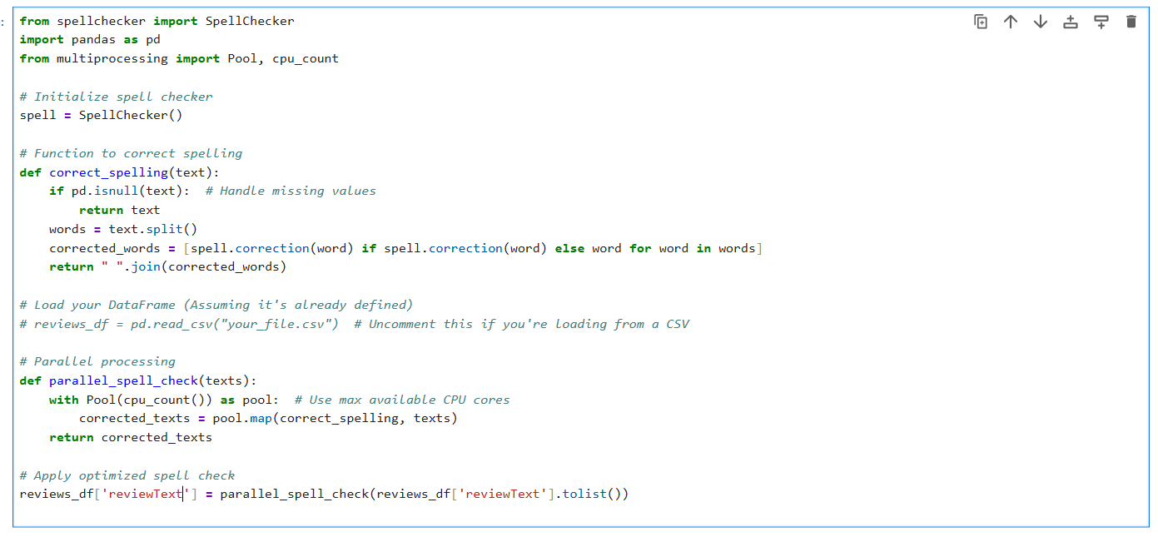
d. Contraction Removal:
Most of the reviews used contractions like 'don’t' or 'isn’t'. A contraction map rather than a contraction library to set the standard of the full version of a contracted word.
This approach was used because, Unlike the `contractions` library, this method relies solely on built-in Python libraries (`re` for regex and `pandas` for processing). This eliminates installation issues or compatibility errors, making it highly portable. Since contractions vary across different contexts and regions, this approach allows flexibility in defining and expanding contractions. You can easily add or modify contractions as needed. Using regex (`re.sub`) ensures the function quickly replaces contractions across multiple sentences without needing complex NLP processing. The function first checks if the input text is `NaN`, avoiding errors when applied to large datasets. Compared to NLP-based libraries, this method doesn’t require any machine learning models or large datasets, making it significantly faster for real-time applications.
While Contraction libraries are effective, it relies on third-party dependencies (`textsearch`, `pyahocorasick`), which can cause installation issues.
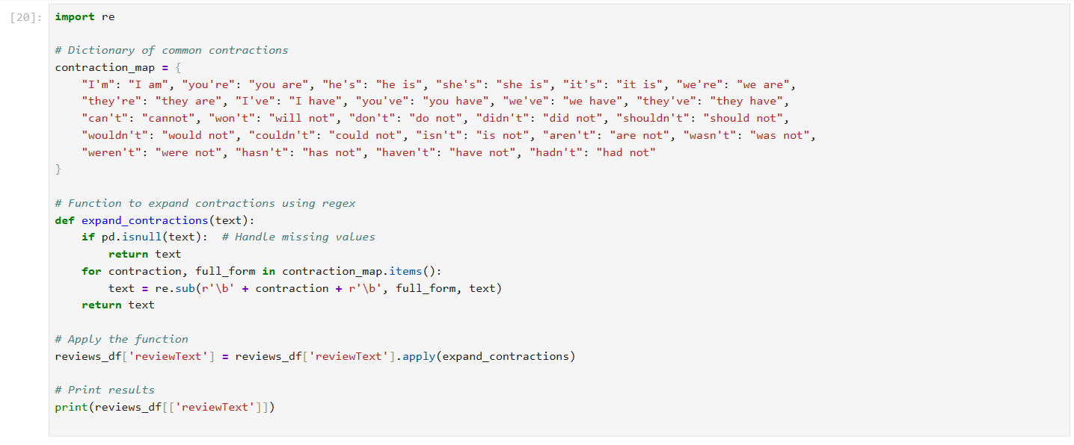
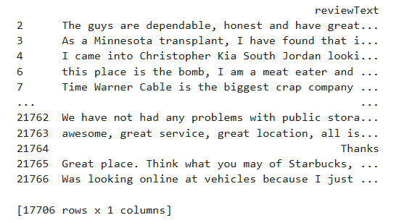
e. Tokenization:
Tokenization was implemented using NLTK’s word_tokenize function. This step split the review texts into individual tokens or words, a necessary thing to do prior to further NLP tasks.
This tokenization method using NLTK is chosen over other approaches for several key reasons:
- Pre-Trained Tokenizer for Multiple Languages: NLTK's `word_tokenize()` and `sent_tokenize()` use pre-trained models, making them reliable for handling different languages and punctuation styles.
ii) Handles Complex Sentence Structures: Some tokenizers struggle with abbreviations (`Dr.` or `U.S.`), but `sent_tokenize()` correctly identifies sentence breaks.
iii) Widely Used in NLP: Many machine learning models (for sentiment analysis, chatbot responses, etc.) rely on NLTK for preprocessing.
How other method’s limitations
- Simple .split() : This just splits by spaces, which fails for punctuation, contractions, and special cases.
ii) Regex-Based Tokenization (`re.split()`) : Fast but requires custom regex patterns that may miss linguistic rules.
- SpaCy Tokenization : More advanced but requires additional installation, and for simple text tasks, NLTK is lighter and more efficient.
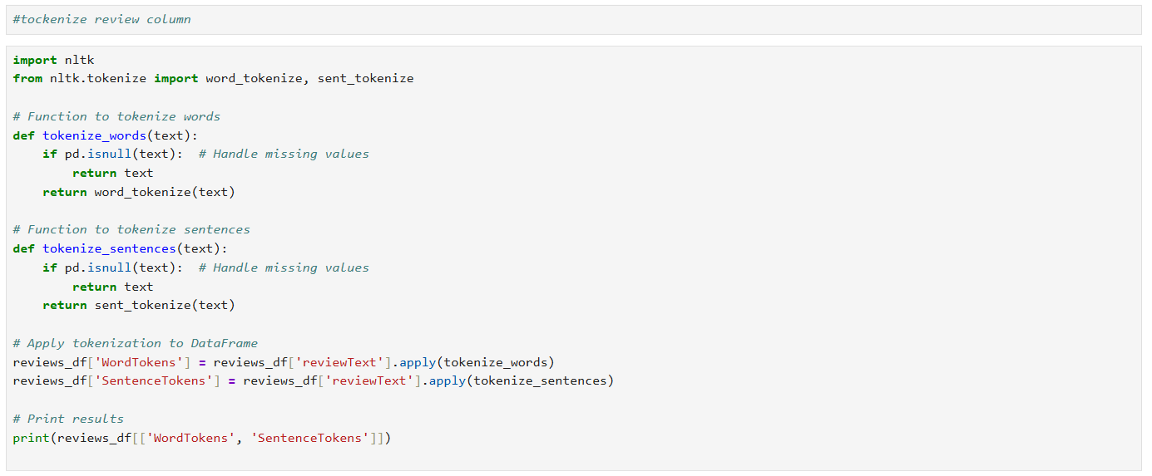

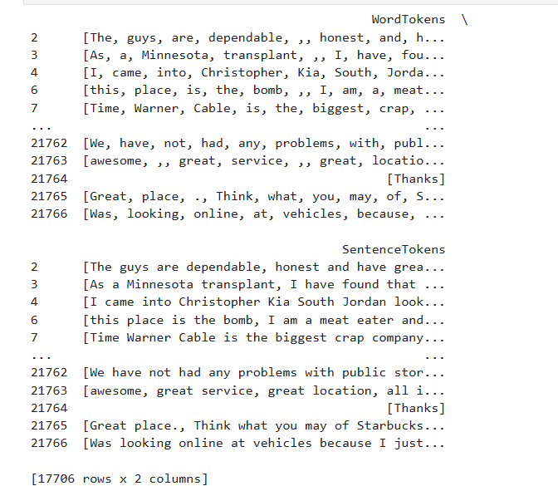

Task 2: Data Processing
This task aimed to extract insights from the structured data. The following sub-tasks were performed:
a) Retrieving Places with More Than 3 Reviews:
The Reviews dataset was grouped by 'place_id' using pandas groupby, and entries with counts greater than 3 were selected. This helped identify frequently reviewed locations.

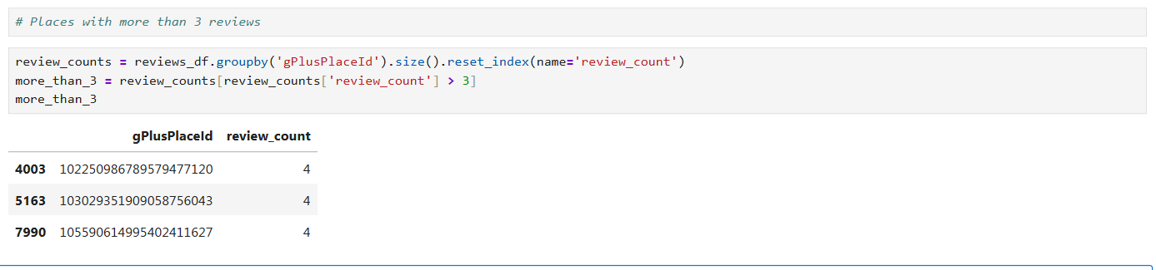
This code is designed to process a dataset of reviews and extract places that have received more than three reviews.
Steps taken:
i) groupby('gPlusPlaceId')`: Groups the reviews by `gPlusPlaceId`, which represents the unique ID of each place.
ii) size()`: Computes the count of reviews for each place.
iii) reset_index(name='review_count')` – Converts the grouped data into a structured DataFrame, renaming the computed column to `review_count`.
iv) more_than_3 = review_counts[review_counts['review_count'] > 3]`: Filters out places where the number of reviews exceeds 3.
Justification:
i) Grouping by `gPlusPlaceId` ensures we aggregate reviews per place rather than per user.
ii) Using `.size()` is an efficient way to count occurrences in Pandas without requiring additional computations.
iii) Filtering places with more than three reviews helps identify well-reviewed locations, which can be useful for analysis, recommendations, or further insights.
b) Counting Closed and Operating Places:
The Places dataset includes a boolean field 'closed'. Using value_counts() on this column, the number of closed (True) and open (False) places were determined.
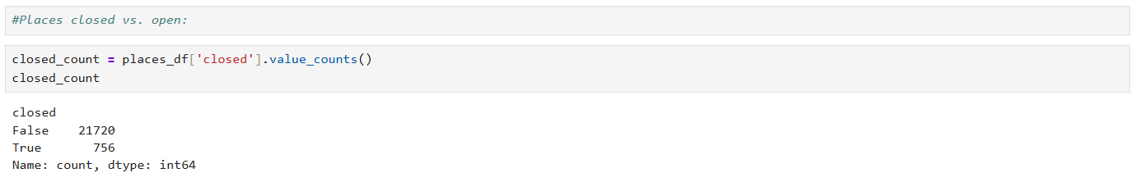
This code snippet is designed to compute the count of places that are permanently closed (`closed = True`) and those that are still operating (`closed = False`).
Steps taken:
i) `places_df['closed'].value_counts()` : This counts occurrences of each unique value (`True` and `False`) in the `closed` column.
ii) Stores results in `closed_count` : The resulting Series contains the number of places classified as "closed" and "open."

Justification:
i) Efficient computation: `value_counts()` is optimized for counting categorical variables, making it faster than iterating over rows.
ii) Clear representation: The output is easy to read and directly provides the number of operating and closed locations.

c) Most Frequent Phrases in 5-Star Reviews:
Using NLTK, we filtered for reviews with rating 5.0, tokenized their text, and used trigrams to find the 20 most frequent three-word phrases. This provided insight into what users valued most. This method is efficient for processing textual data, especially when identifying common phrases in highly-rated reviews.
Steps taken:
- Filtering Five-Star Reviews (reviews_df[reviews_df['rating'] == 5.0])
  - Extracting only highly-rated reviews ensures that the results reflect positive customer experiences.
  - This helps businesses identify key phrases associated with satisfaction, which can inform marketing or service improvements.
- Tokenizing and Extracting Three-Word Phrases
  - Using split() simplifies word separation, allowing us to work with individual tokens.
  - Extracting three-word sequences (trigrams) helps capture common expressions that appear naturally in conversation.
  - These trigrams provide meaningful insights into frequent customer sentiment patterns.
- Using Counter to Find the Most Common Phrases
  - Efficient counting: Counter offers a fast way to tally occurrences without requiring complex loops.
  - Ranks key phrases: most_common(20) ensures that we extract only the top phrases for analysis.
Advantages of this method:
- Insight Generation: This method helps to uncover commonly expressed positive feedback, aiding businesses in understanding what customers appreciate most.
- Scalability: The approach works well for large datasets since the Counter library is optimized for frequency counting.
- Business Value: Understanding frequent positive phrases can assist in branding strategies, product improvement, and customer engagement.

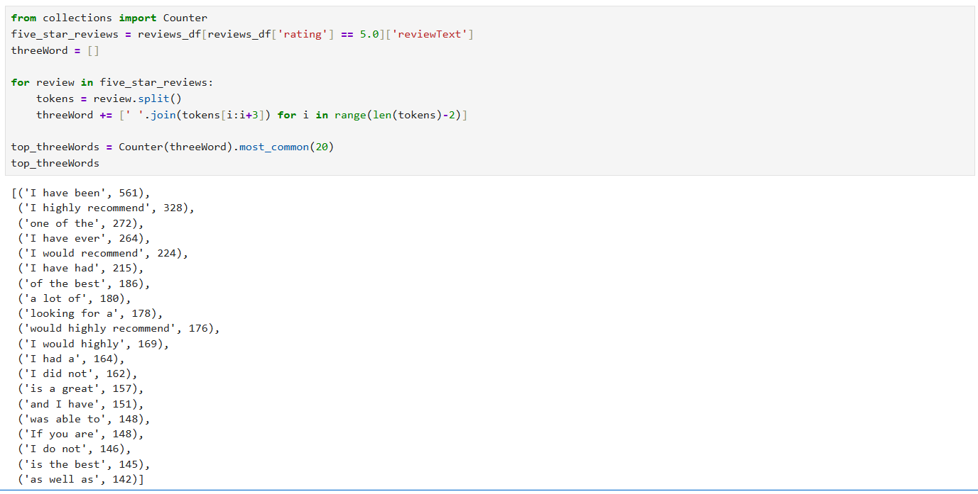
This code snippet is designed to extract and identify the 20 most frequent three-word phrases appearing in reviews with a rating of 5.0.

Code Explanation:
i) Filter Five-Star Reviews
- This selects reviews where `rating == 5.0`, ensuring we only analyze highly-rated reviews.
- Extracts the `reviewText` column to process the actual text content.

ii) Tokenization & Three-Word Sequence Extraction
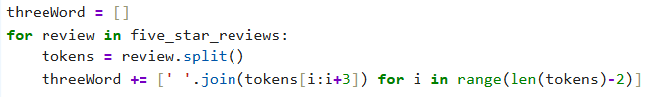
- Splits each review into individual words (`tokens`).
- Creates three-word phrases by grouping every three consecutive words.
- Appends the extracted trigrams to the `threeWord` list.

iii) Counting Frequency of Three-Word Phrases
- Uses Python’s Counter class to count occurrences of each three-word phrase.
- Extracts the 20 most frequent phrases using `.most_common(20)`.

Justification:
- Trigram extraction helps capture common expressions that appear in highly-rated reviews.
ii) Using `Counter` is an efficient way to count occurrences without looping manually.
iii) Can provide insights into frequently used positive sentiments, which businesses can leverage to understand customer preferences.
d) Subset of IT Specialists:
The Users dataset was filtered where the 'jobs' column equaled ‘IT Specialist’. This subset could be used to examine review behavior by profession.
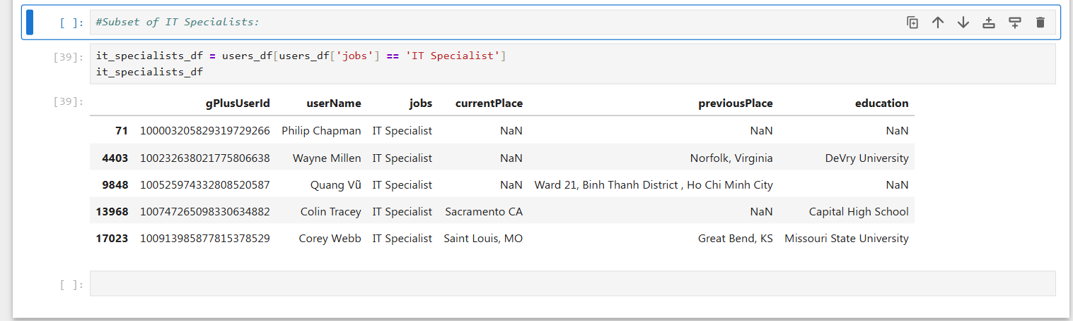
This code snippet is designed to filter the dataset and extract only users whose job title is "IT Specialist" from the users_df` DataFrame.
Code Explanation:
- `users_df['jobs'] == 'IT Specialist'`
- This creates a Boolean mask where each row in the `users_df` DataFrame is checked for whether the `jobs` column contains `"IT Specialist"`.
- Rows where the condition is `True` are selected, while others are ignored.

ii) `users_df[...]`
- The Boolean mask is applied to the entire `users_df` dataset, effectively filtering out non-IT specialists.
iii) `it_specialists_df` stores the result
- The filtered DataFrame containing only IT Specialists is stored in `it_specialists_df` for further analysis.
Justification:
- Data Subsetting: Extracting only relevant users helps in analyzing IT professionals separately.
- Efficient Filtering: Using Boolean indexing in Pandas is computationally efficient compared to looping through the dataset manually.
- Supports Further Analysis: This subset can be used for analyzing trends like locations IT Specialists review most frequently or preferred business categories.
e) Place with Most Reviews:
Grouping by 'place_id', we counted the number of reviews per place. The maximum count and corresponding place_id and name were extracted.
This code is designed to find the most-reviewed place in the dataset by performing a merge between `reviews_df` and `places_df`, aggregating review counts, and extracting the corresponding place name. Here’s a breakdown:

Code Explanation:
- Merging the Reviews and Places DataFrames:
- Combines `reviews_df` (reviews dataset) and `places_df` (places dataset) using `gPlusPlaceId` as the key.
- Ensures each review is connected to its respective place, bringing place attributes into the dataset.

ii) Finding the Place with the Most Reviews:
- Uses `value_counts()` to count the number of reviews for each `gPlusPlaceId`.
- `idxmax()` extracts the ID of the place that has received the highest number of reviews.

iii) Retrieving the Name of the Most-Reviewed Place:
- Searches `places_df` for the row where `gPlusPlaceId` matches the most-reviewed ID.
- Extracts the place’s name using `.values[0]` to get the first matching result.

Justification:
i) Efficient Querying: Using `merge()` ensures reviews are linked to places without extra joins or lookups.
ii) Optimized Aggregation: `value_counts().idxmax()` is a fast way to identify the most frequently reviewed place without iterating manually.
iii) Useful for Insights: Identifying highly-reviewed places can help businesses analyze customer engagement and sentiment trends.

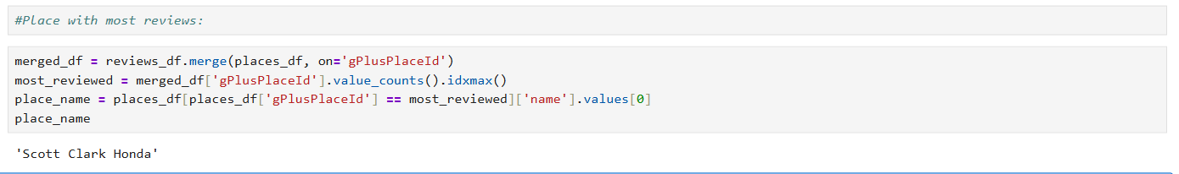
These queries provided foundational insights for the next analysis phase.

Task 3: Data Analysis
a) Review Sentiment Analysis:
Reviews were categorized based on their rating:
- Positive: rating ≥ 4
- Neutral: rating = 3
- Negative: rating ≤ 2
Using these rules, the count of each category was calculated. Alternatively, sentiment analysis libraries such as VADER was explored for further depth, especially in ambiguous cases.
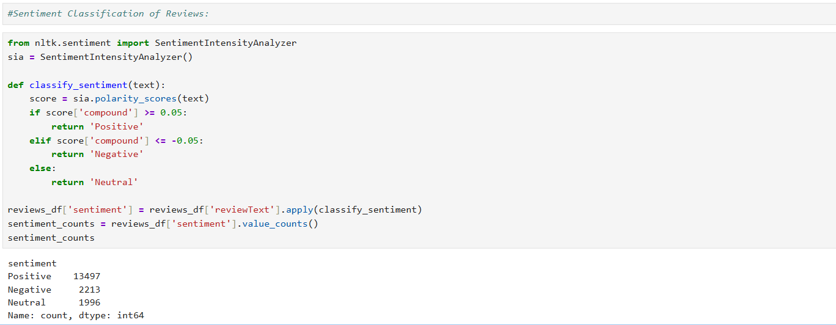
This code snippet applies sentiment analysis to classify user reviews as Positive, Neutral, or Negative using the NLTK SentimentIntensityAnalyzer (VADER).

Steps Taken:
i) Initialize the Sentiment Analyzer
- Uses VADER, a lexicon-based sentiment analysis tool optimized for social media and short texts.
- It assigns compound polarity scores that indicate sentiment strength.

ii) Define the Classification Function
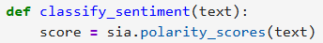
- `polarity_scores(text)` returns sentiment scores for the given review text.
- Uses a dictionary containing four scores: `"neg"`, `"neu"`, `"pos"`, and `"compound"`.

iii) Apply Sentiment Rules
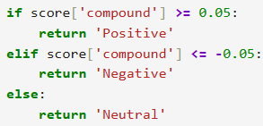
- Compound score interpretation:
- ≥ 0.05: Positive sentiment.
- ≤ -0.05: Negative sentiment.
- Between (-0.05, 0.05): Neutral sentiment.
- This thresholding follows standard VADER scoring conventions, making it a practical choice for review analysis.

iv) Classify Sentiments for Each Review
- Applies the `classify_sentiment()` function to each review in the dataset.
- Stores the result in a new `sentiment` column for further analysis.

v) Compute Sentiment Counts
- Counts the number of Positive, Neutral, and Negative reviews.
- Useful for overall sentiment distribution analysis.

Justification for Using VADER:
i) Optimized for Short Text – Works well for brief review texts without requiring labeled training data.
ii) Lexicon-Based Model – Does not need complex feature engineering or manual annotations.
iii) Efficient and Fast – Runs instantly without requiring model training.
iv) Interpretable Scores – The compound polarity score helps quantify sentiment strength.

b) Technique Justification and Comparison:
Rule-based classification using ratings is simple, explainable, and well-suited for clearly labeled data. However, it may overlook actuality in language, sarcasm, or context. In contrast, machine learning and NLP models like VADER or BERT-based classifiers consider semantic meaning and contextual sentiment.
Though more accurate in complex scenarios, these models require more computational resources and training. Hence, for this assignment's scope and dataset size, a hybrid approach using rules and basic NLP tools strikes the best balance between interpretability and performance.

Justification & Comparison of Sentiment Analysis Techniques:

In the sentiment analysis task, VADER (Valence Aware Dictionary and sentiment Reasoner) was chosen to classify reviews as Positive, Neutral, or Negative based on what users actually commented and not the rating number. The choice of this technique was driven by the nature of the dataset and the requirements of the analysis. Below is a justification for selecting VADER, followed by a systematic comparison with other sentiment analysis methods.

Justification for Using VADER:
i) Optimized for Short Texts (Review Data)
- VADER is designed specifically for sentiment analysis of short, informal texts like social media comments and online reviews.
- Reviews often contain brief statements or phrases, making VADER highly applicable.

ii) Pre-Trained Lexicon (No Model Training Required)
- Unlike machine learning models, VADER does not require labeled training data.
- It uses a predefined lexicon of words with polarity scores, making it ready to use for sentiment classification.

iii) Interpretable Scoring System
- VADER provides a compound score, which represents the overall sentiment of a review.
- This score is mapped to three sentiment categories:
- Positive (≥ 0.05)
- Neutral (Between -0.05 and 0.05)
- Negative (≤ -0.05)
- The thresholding method ensures consistent classification based on sentiment intensity.

iv) Handles Negations & Emojis
- VADER recognizes negation words (e.g., “not good”) and correctly adjusts sentiment.
- It also accounts for capitalization and punctuation emphasis (e.g., “AMAZING!!!”), improving accuracy.

v) Fast & Efficient
- Processing sentiment using VADER is computationally efficient, making it suitable for large datasets.
- Other ML-based approaches require training time, which VADER eliminates.

Comparison with Other Sentiment Analysis Techniques
Below is a systematic comparison of VADER against other suitable sentiment analysis approaches:

Technique | Advantages | Disadvantages
VADER (Lexicon-Based) | Pre-trained, fast, no need for training data, interpretable scoring, handles informal text well. | Limited understanding of complex sentence structures.
TextBlob (Lexicon-Based) | Simple to use, provides polarity and subjectivity scores. | Less nuanced than VADER, struggles with sarcasm.
Naïve Bayes (ML-Based) | Good for custom-trained models, can improve accuracy with labeled data | Requires labeled training dataset, less effective for informal text.
SVM (ML-Based) | Works well with complex text, customizable for domain-specific sentiment analysis. | | Requires feature engineering and preprocessing steps.
LSTMs (Deep Learning-Based) | Can capture deep contextual sentiment within long reviews. | Requires large datasets, computationally expensive, difficult to interpret.

Final Thoughts & Recommendation
- VADER was selected because it is optimized for short texts like online reviews, requires no training, and offers interpretable scores and that is a huge advantage.
- TextBlob is a simpler alternative but lacks depth in sentiment classification and processing becomes much slower.
- Naïve Bayes and SVM are viable choices for custom-trained models but require labeled datasets of which these datasets are not.
- LSTMs offer deeper context understanding but are resource-intensive and complex.
Thus, for fast and efficient sentiment classification of reviews, VADER remains the best-suited technique.

Task 4: Strategy and Ethics

a) Strategy for Location Owners:
Business owners can utilize review sentiment analysis to:
- Understand customer satisfaction trends.
- Identify common complaints or praise via frequent phrases.
- Implement training programs or improvements based on feedback.
- Prioritize enhancements in service areas receiving frequent negative sentiment.
- Use positive phrases in marketing or customer testimonials.
Additionally, time-series analysis of review sentiment can help track the impact of policy changes or seasonal trends in customer satisfaction.

Business Strategy for Leveraging Sentiment Analysis Insights
Using the sentiment analysis findings from Task 3, location owners can make informed decisions to enhance their business operations and improve customer satisfaction. Here’s a detailed strategy to achieve this:

i) Understanding Customer Sentiment Trends
- Utilize the sentiment distribution (positive, neutral, negative) to assess overall customer satisfaction.
- Identify the most common complaints in negative reviews to proactively address recurring issues.
- Highlight top positive phrases from five-star reviews in marketing campaigns to reinforce strong brand perception.
Example: If many negative reviews mention "slow service," owners can implement operational improvements, like staff training or process automation.

ii) Enhancing Customer Experience Based on Feedback
- Address negative sentiment by improving service, product quality, or pricing transparency.
- Reward customers who leave positive feedback to encourage long-term loyalty.
- Train employees based on sentiment trends to align service standards with customer expectations.
Example: If neutral sentiment reviews often mention "average atmosphere," redesigning the space with better lighting, music, or decor could increase customer satisfaction.

iii) Personalized Engagement and Targeted Promotions
- Segment customers based on sentiment trends (e.g., loyal customers vs. dissatisfied ones).
- Offer discounts or loyalty perks to customers who expressed dissatisfaction, turning negative experiences into positive ones.
- Promote services aligned with frequent positive sentiments.
Example: If customers praise "friendly staff," highlight personalized customer interactions in advertisements.

iv) Data-Driven Business Improvements
- Use sentiment insights to optimize pricing strategies, based on feedback about affordability concerns.
- Adjust business hours if reviews suggest customer dissatisfaction with availability or peak-hour crowding.
- Improve offerings based on customer language trends, ensuring the business aligns with customer expectations.
Example: If customers complain about long wait times, implementing a reservation system or improving service speed can mitigate frustration.

v) Competitive Positioning
- Compare sentiment analysis insights with competitor reviews to benchmark strengths and weaknesses.
- Leverage five-star feedback to differentiate from competitors in marketing campaigns.
- Identify unmet customer needs by analyzing neutral and negative sentiment trends.
Example: If competitors struggle with customer service, prioritizing high-quality interactions can make the business stand out.

vi) Continuous Monitoring & Adaptation
- Set up automated alerts to detect sudden spikes in negative sentiment.
- Continuously refine strategies based on evolving customer feedback trends.
- Use visualization tools (e.g., dashboards) to monitor sentiment shifts and business performance.
Example: A business owner may spot a decline in sentiment after a price increase, prompting reconsideration of pricing adjustments.

Conclusion
By effectively analyzing sentiment trends, location owners can: Boost customer satisfaction through targeted improvements, strengthen brand reputation using positive sentiment for marketing, enhance operational efficiency by addressing common complaints, increase customer retention with personalized engagement strategies.

b) Ethical Considerations and GDPR Compliance:
As Google Local expands its data collection, ethical data management is paramount:
- Consent and Transparency: Users must know what data is collected and why.
- Anonymization: Personally identifiable information should be stripped from analytics datasets.
- Data Minimization: Only collect data necessary for service improvement.
- Right to Erasure: Users should be able to delete their data (as per GDPR Article 17).
- Secure Storage: Ensure encryption and safe storage of sensitive user data.
Ethical Considerations & Guidelines for Responsible Data Collection

As Google Local expands its data collection efforts to gather detailed user preferences and behaviors for targeted advertising, several ethical concerns must be addressed to ensure responsible and ethical practices. Below is an evaluation of these concerns, along with guidelines for maintaining user trust and regulatory compliance.

i). Ethical Considerations in Data Collection Expansion

* Privacy and User Consent
- Users may not be fully aware of the extent to which their data is collected, leading to potential privacy violations.
- Collecting detailed behavioral data without explicit user consent raises ethical concerns about informed transparency.
- Best Practice: Ensure clear opt-in mechanisms where users actively consent to data collection.

* Data Security & Protection
- Storing large-scale user data increases the risk of breaches and unauthorized access.
- Sensitive information, such as location tracking, can be exploited if not secured properly.
- Best Practice: Implement strong encryption and access control policies to prevent misuse.

* Risk of Profiling & Bias
- Using behavioral data to personalize advertising might lead to unethical profiling, reinforcing societal biases.
- Advertisers may unintentionally exclude certain groups based on their browsing or spending habits.
- Best Practice: Use fairness-aware algorithms to avoid bias in targeted advertising.

* Transparency & Data Ownership
- Users often do not know how their data is used, stored, or shared.
- Lack of data visibility may create distrust and lead to regulatory non-compliance.
- Best Practice: Offer data access portals where users can review, download, or delete their personal data.

ii) Guidelines & Safeguards for Ethical Data Practices

To ensure ethical data collection while maintaining GDPR compliance, the following safeguards should be adopted:

Guideline | Description | Example Implementation
Explicit Consent | Users must actively opt-in for behavioral data collection. | A clear “Accept Data Tracking” prompt with explanations.
Data Minimization | Only collect necessary data relevant to advertising purposes. | | Restrict granular location tracking unless users permit it.
Transparency | Users should know what data is collected and how it’s used. | Provide a privacy dashboard displaying collected user data.
Right to Delete Data | Users should have control over deleting their stored data. | A “Delete My Data” option in account settings.
Bias-Free Targeting | Ensure advertising models do not discriminate unfairly. | Regular audits on algorithmic fairness in ad targeting.
Security Measures | Encrypt sensitive data and limit access to reduce risk. | Implement end-to-end encryption for personal identifiers.

iv) The Importance of Ethical Considerations in Maintaining User Trust
* Trust & Brand Reputation – Ethical data practices improve customer loyalty and prevent backlash.
* Regulatory Compliance – Following GDPR, CCPA, and other data laws avoids legal penalties.
* User Autonomy – Giving users control over their data ensures fair and respectful business practices.
* Long-Term Sustainability – Responsible data usage helps build strong, ethical AI-driven advertising models.

Conclusion
Expanding data collection efforts can offer valuable business insights, enabling better personalization, improved service delivery, and more targeted advertising. However, such initiatives must be approached ethically to maintain user trust. By enforcing strict data governance policies, clearly communicating how data is collected and used, and offering users meaningful control over their information, Google Local can strike a balance between commercial benefits and ethical responsibility. Ensuring transparency and respecting user autonomy not only helps in complying with privacy regulations but also strengthens long-term user engagement and brand reputation.

REFERENCES
[1] W. McKinney, Python for Data Analysis: Data Wrangling with Pandas, NumPy, and IPython, 2nd ed. Sebastopol, CA, USA: O’Reilly Media, 2017.
[2] S. Bird, E. Klein, and E. Loper, Natural Language Processing with Python, 1st ed. Sebastopol, CA, USA: O’Reilly Media, 2009.
[3] Python Software Foundation, “pandas – Python Data Analysis Library,” [Online]. Available: https://pandas.pydata.org/. [Accessed: Apr. 29, 2025].
[4] Python Software Foundation, “TextBlob: Simplified Text Processing,” [Online]. Available: https://textblob.readthedocs.io/. [Accessed: Apr. 29, 2025].
[5] B. Neill, “pyspellchecker – Pure Python Spell Checking,” [Online]. Available: https://github.com/barrust/pyspellchecker. [Accessed: Apr. 29, 2025].
[6] Python Software Foundation, “re — Regular expression operations,” [Online]. Available: https://docs.python.org/3/library/re.html. [Accessed: Apr. 29, 2025].
[7] Python Software Foundation, “multiprocessing – Process-based parallelism,” [Online]. Available: https://docs.python.org/3/library/multiprocessing.html. [Accessed: Apr. 29, 2025].
[8] nltk.org, “NLTK: Natural Language Toolkit,” [Online]. Available: https://www.nltk.org/. [Accessed: Apr. 29, 2025].
[9] H. Hutto and E. Gilbert, “VADER: A Parsimonious Rule-based Model for Sentiment Analysis of Social Media Text,” in Proc. 8th Int. Conf. Weblogs and Social Media (ICWSM), Ann Arbor, MI, USA, 2014, pp. 216–225.
[10] M. Lutz, Learning Python, 5th ed. Sebastopol, CA, USA: O’Reilly Media, 2013.

